**Lab Application**

Technologies:

Back end:

1. Spring boot

2. Spring JPA

3. Java 8

Front end:

1. React JS

2. Material UI

Data Base:

1. MySql
2. Please find attachment for data

Application landing page: <http://localhost:3000> (default react port)

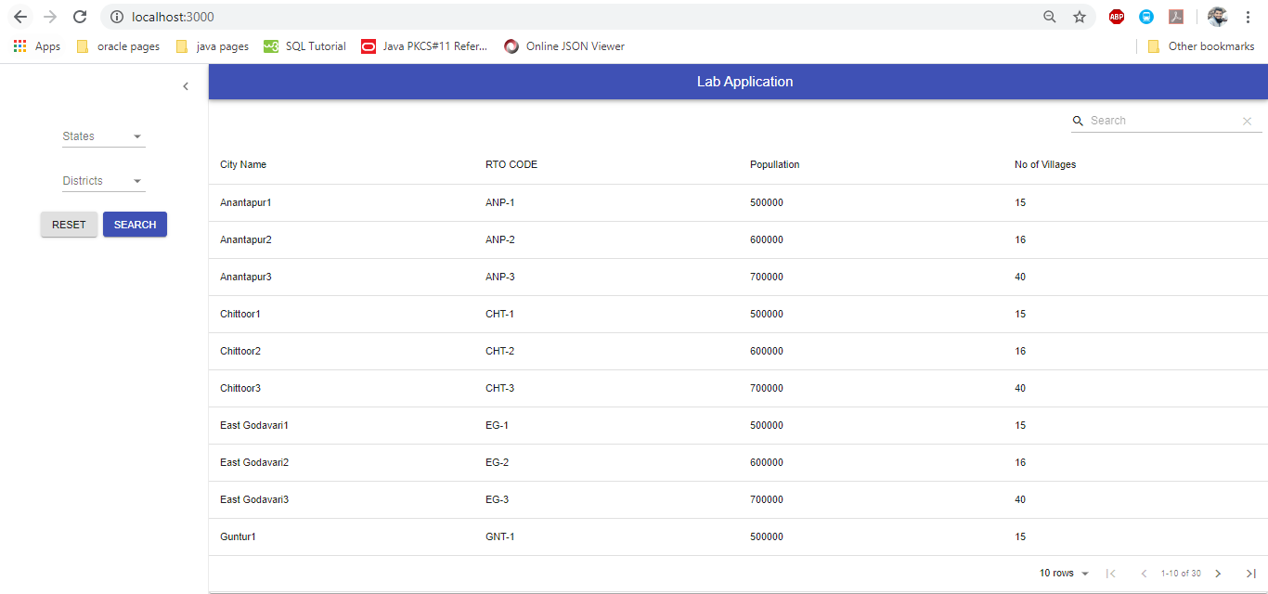

States select:

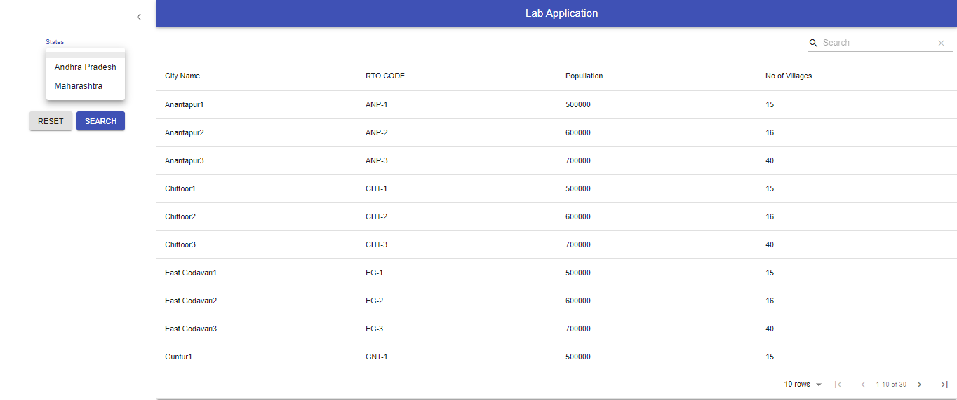

Districts selection:

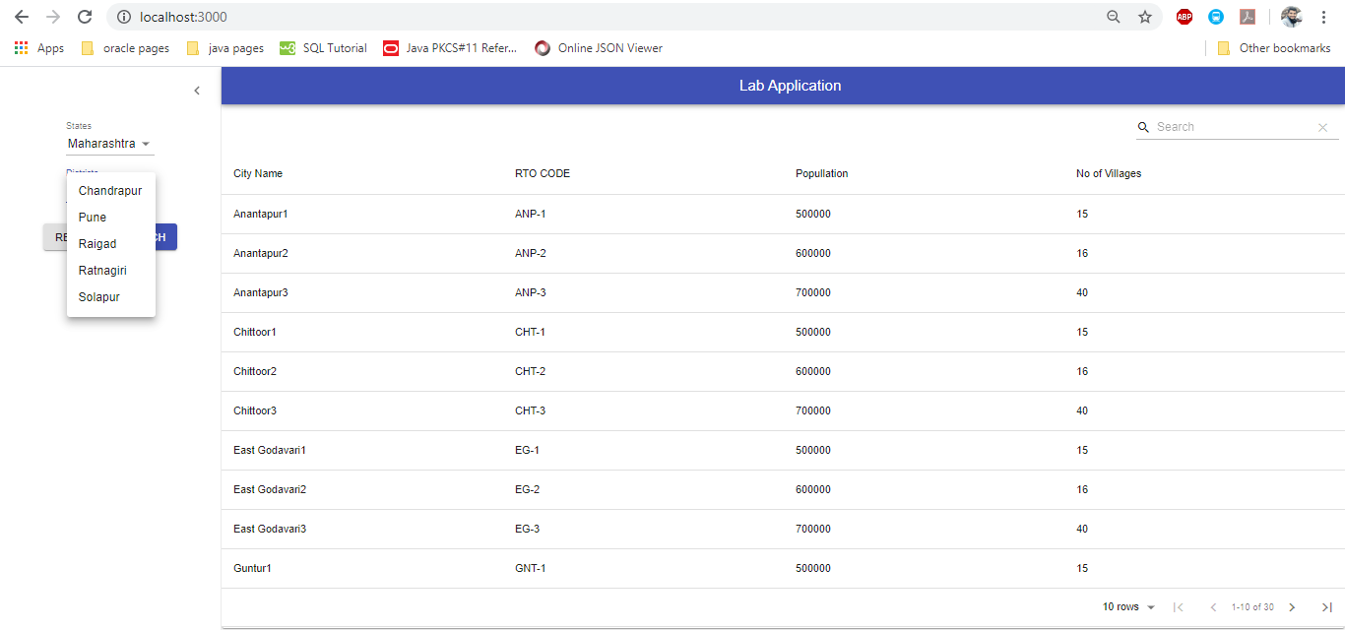

Search Click:

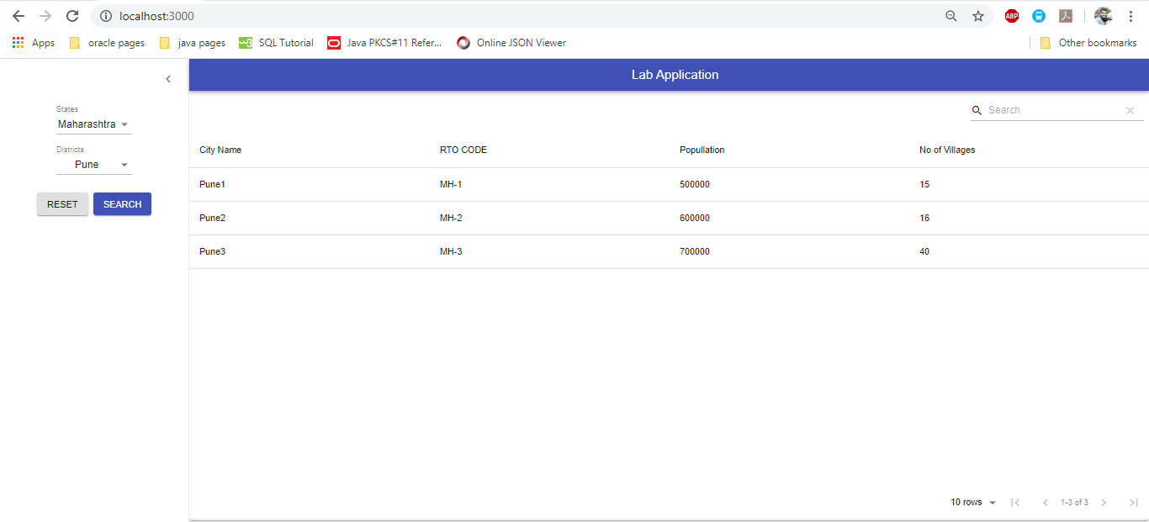

Reset click:

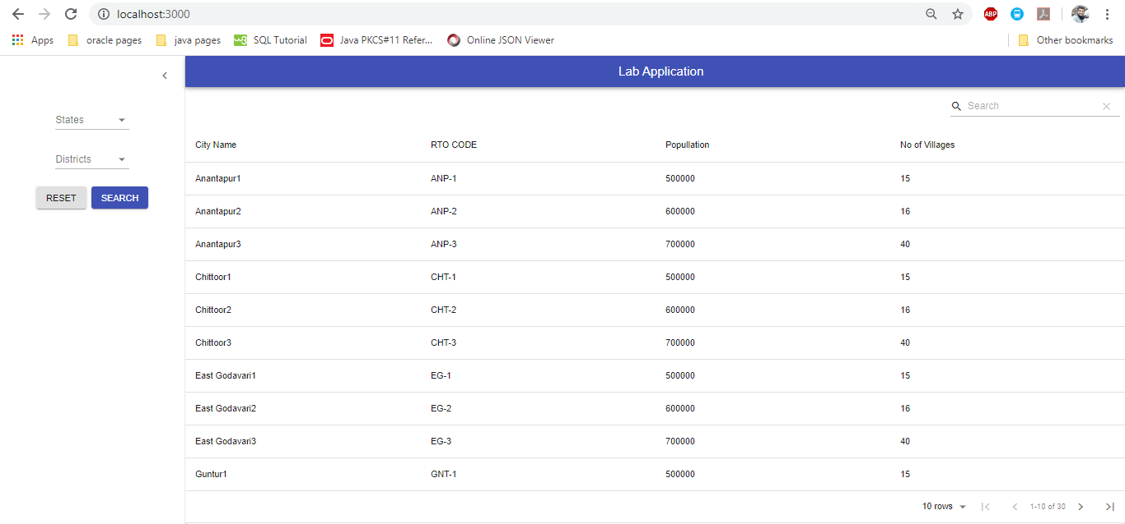

Backend API calls:

1. localhost:8080/lab/get
2. localhost:8080/lab/getStates
3. localhost:8080/lab/getDistricts?states=Andhra Pradesh
4. localhost:8080/lab/getDistrictsData?states=Maharashtra
5. localhost:8080/lab/getCitiesData?district=Pune

Please refer mail attached postman collection.